ATAR Physics Year 11
Semester Two Examination, 2015
Question/Answer Booklet

Student Name: ___________________________________

Time allowed for this paper
Reading time before commencing work: 10 minutes
Working time for paper: 3 hours

Materials required/recommended for this paper
To be provided by the supervisor
This Question/Answer Booklet and the Formulae and Constants Sheet

To be provided by the candidate
Standard items: pens (blue/black preferred), pencils (including coloured), sharpener, correction tape/fluid, eraser, ruler, highlighters
Special items: non-programmable calculators approved for use in the WACE examinations, drawing templates, drawing compass and a protractor

Important note to candidates
No other items may be taken into the examination room. It is your responsibility to ensure that you do not have any unauthorised notes or other items of a non-personal nature in the examination room. If you have any unauthorised material with you, hand it to the supervisor before reading any further.

Structure of this paper
Section | Number of questions available | Number of questions to be answered | Suggested working time (minutes) | Marks available | Marks Attained
Section One: Short answers | 13 | 13 | 54 | 54 (30%) | /54
Section Two: Problem-solving | 7 | 7 | 90 | 90 (50%) | /90
Section Three: Comprehension | 2 | 2 | 36 | 36 (20%) | /36
 |  |  |  | 180 (100%) | /180

Instructions to candidates
Write your answers in the spaces provided beneath each question. The value of each question (out of 150) is shown following each question.

The enclosed Physics: Formulae and Constants Sheet may be removed from the booklet and used as required.

Calculators satisfying conditions set by the Curriculum Council may be used to evaluate numerical answers.

Answers to questions involving calculations should be evaluated and given in decimal form.
Give final answers to three significant figures and include appropriate units where applicable.

When calculating numerical answers, show your working or reasoning clearly. Despite an incorrect final answer, credit may be obtained for method and working, providing this is clearly and legibly set out.

Questions containing specific instructions to show working should be answered with a complete, logical, clear sequence of reasoning showing how the final answer was arrived at; correct answers which do not show working will not be awarded full marks.

Questions containing the instruction estimate may give insufficient numerical data for their solution. Students should provide appropriate figures to enable an approximate solution to be obtained. When estimating numerical answers, show your working or reasoning clearly. Give final answers to a maximum of two significant figures and include appropriate units where applicable.

Section One: Short answers (54 Marks)
This section has thirteen (13) questions. Answer all questions. Write your answers in the spaces provided.
Suggested working time: 54 minutes.

Question 1 (5 marks)
A model rocket has a mass at launch of 1.5 kg (of which 60% is fuel).
(a) On the diagram at right, sketch and label the two forces acting on the rocket as it lifts off at launch. (1 mark)

(b) If the initial acceleration of the rocket is 15 m/s², calculate the thrust force of its engine at launch. (2 marks)

(c) The acceleration of the rocket increases as it flies higher and higher. Suggest why this would happen. (2 marks)

Question 2 (4 marks)
A piece of iron wire is heated in a bunsen burner flame, and then cooled by being dropped into a large beaker of cold water.
(a) Explain how the heated piece of iron wire can be at a higher temperature than the cold water in the beaker, yet have less internal energy. (2 marks)

(b) Describe what happens at the molecular level as the piece of iron wire cools down after being dropped into the water (the water warms up slightly). (2 marks)

Question 3 (4 marks)
State which of the three types of nuclear radiation (α, β, γ), that results from natural radioactive decay, best matches each of the following properties.

the radiation that is most ionising

the radiation consisting of particles of least mass

the radiation that is emitted at the lowest speed

the radiation that is not deflected by an electric field

Question 4 (3 marks)
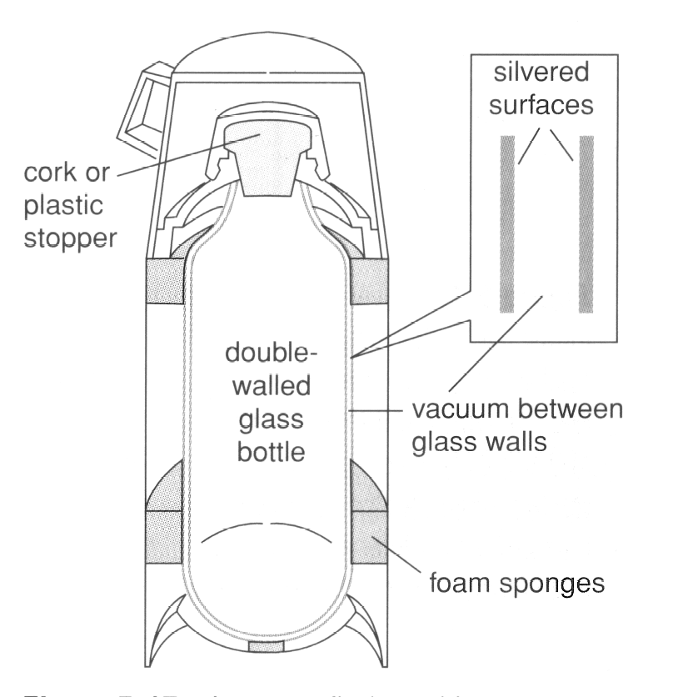
A cross-section of a thermos flask is shown in the diagram at right. Describe how each of the following features of the thermos flask reduces heat loss.
silvered surfaces:

vacuum between glass walls:

cork stopper:

Question 5 (4 marks)
A Transperth train leaves Mandurah train station and accelerates steadily up to its cruising speed of 120 km/hr within a distance of 750 m from the station platform. Calculate
(a) the acceleration of the train. (2 marks)

(b) the time it takes to accelerate up to its cruising speed. (2 marks)

Question 6 (4 marks)

The heating elements in a toaster are designed to get red hot in order to toast bread placed in the toaster. A typical toaster draws a current of 7.5 A when operating on household voltage (240 V).
(a) Calculate the resistance of the heating elements and the power produced by the toaster when in normal operation. (2 marks)

(b) Describe how and explain why the current through the heating element changes when the toaster is switched on. (2 marks)

Question 7 (4 marks)
The diagram below shows a sound wave moving through air at 25°C. The sinusoidal graph above the sound wave indicates the variation in air pressure as the wave travels.
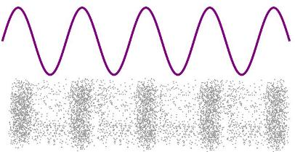
6.24 m

Pressure
Variation

SOUND
WAVE

(a) Calculate the value of each of the following quantities for this sound wave.
Wavelength: (1 mark)
Frequency: (1 mark)
Period: (1 mark)
(b) On the pressure variation graph above, superimpose a sinusoidal graph to show the variation in particle displacement as the wave travels through the air. (1 mark)
Question 8 (5 marks)
A hanging mass of 175 g is connected to a 450 g block sitting on a table via a string and pulley as shown in the diagram at right. The two masses accelerate under the influence of gravity. The force of friction, F_{f}, acting on the block is 0.85 N.
450 g
T
T
F_{f}
W
175 g
(a) Calculate the acceleration of the 450 g block. (3 marks)

(b) Calculate the tension T in the string. (2 marks)

Question 9 (4 marks)


Jimi is practicing guitar in his room with the door open, as shown in the diagram at right. With reference to relevant physics principles, explain why Joni, in the hallway outside his room, can hear the sound of the guitar but not see Jimi.

Question 10 (4 marks)
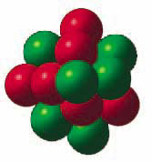
(a) Small nuclei, such as the carbon-12 nucleus, are quite stable despite the fact that the six protons in the nucleus repel each other strongly. Why is this? (2 marks)

(b) Why are large nuclei, such as those of radium or plutonium, less stable and therefore prone to radioactive decay? (2 marks)

Question 11 (4 marks)
A hair dryer is plugged into a domestic power point. Explain each of the following features.

(a) The switch on the power point is located on the active wire. (2 marks)

(b) The hairdryer does not need an earth wire. (2 marks)

Question 12 (4 marks)
For the circuit shown at right state the value of each of the quantities listed below (no working out needs to be shown, just the answers)
R₁ = 6 Ω
R₃ = 11 Ω
R₂
I₂ = 0.15 A
6 V
I₁ = 0.45 A

(a) voltage drop across R₁

(b) current through R₃

(c) size of resistor R₂

(d) total resistance of the circuit

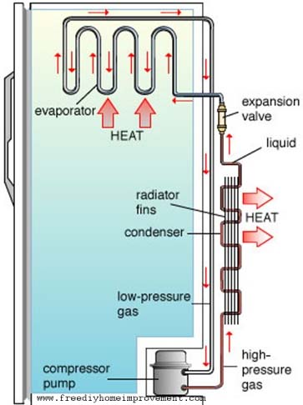
Question 13 (5 marks)
The schematic diagram at right shows the internal workings of a refrigerator.
(a) Explain how the refrigerator operates, making sure to mention all the changes of state involved in the process. (3 marks)

(b) Explain why metal fins are attached to the external pipes and why they are painted black. (2 marks)

END OF SECTION ONE
Section Two: Problem Solving (90 Marks)
This section has seven (7) questions. Answer all questions. Write your answers in the spaces provided.
Suggested working time: 90 minutes.

Question 14 (14 marks)

An electric kettle contains 450 mL of water at an initial temperature of 18°C. The kettle operates on mains voltage (240 V) and draws a current of 6.25 A when switched on. The kettle is 90% efficient at converting electrical energy into thermal energy in the water.
(a) Calculate the amount of heat that the kettle supplies to the water every second after it is switched on. (2 marks)

(b) How much heat is needed by the water to reach boiling point (100°C)? (2 marks)

(c) How long will it take for the water to reach boiling point? (2 marks)

(d) If the kettle remains on after the water reaches boiling point, calculate the rate at which the water boils away (express your answer in g/sec). (3 marks)

(e) Describe, in terms of the kinetic theory, how the heat absorbed after the water reaches boiling point affects the molecules of water. (3 marks)

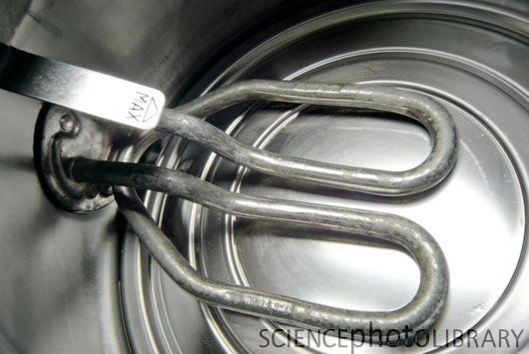
(f) The manufacturer of the electric kettle placed the heating element very close to the bottom of the kettle in order to maximise its efficiency. Briefly explain the benefit of this design. (2 marks)

Question 15 (12 marks)
The first few steps of the natural decay series of uranium-238, via the radioactive elements thorium-234 and protactinium-234m (²³⁴₉₁Pa∗), are shown below.

²³⁸₉₂U → ²³⁴₉₀Th → ²³⁴₉₁Pa∗ → ²³⁴₉₁Pa → ²³⁴₉₂U

(a) Write balanced nuclear equations for
(i) the first decay in the series, uranium-238 into thorium-234 (1 mark)

(ii) the third decay in the series, protactinium-234m into protactinium-234 (1 mark)

(iii) the fourth decay in the series, protactinium-234 into uranium-234 (1 mark)

A radiation detector is used to measure the level of radioactivity near a sample of protactinium-234m over a period of several minutes. The results obtained are shown in the following table:

Activity A (Bq) | 360 | 302 | 256 | 216 | 184 | 158 | 138 | 121 | 106 | 84 | 56 | 46 | 42
Time t (s) | 0 | 20 | 40 | 60 | 80 | 100 | 120 | 140 | 160 | 200 | 300 | 400 | 500

(b) Use these results to plot a graph of activity against time on the graph paper supplied on the next page. (4 marks)

(c) From this graph:
(i) estimate the level of background radiation. (1 mark)

(ii) calculate the half-life of Pa-234m. (2 marks)



(d) Using your value of half-life from above, calculate the expected level of activity after 350 seconds. (2 marks)

Question 16 (10 marks)
A 12.0 V battery is connected to a circuit with four resistors as shown in the diagram below. A current of 0.95 A flows through the 12 Ω resistor.

12.0 V
R
12 Ω
15 Ω
22 Ω

A

B

I
0.95 A

(a) Calculate the potential difference (voltage) between points A and B. (2 marks)

(b) Find the current flowing through the 15 Ω resistor. (2 marks)

(c) Determine the rate at which heat is being produced in the 22 Ω resistor. (2 marks)

(d) What is the current I from the battery? (2 marks)

(e) Find the value of the resistance R in series with the battery. (2 marks)

Question 17 (15 Marks)
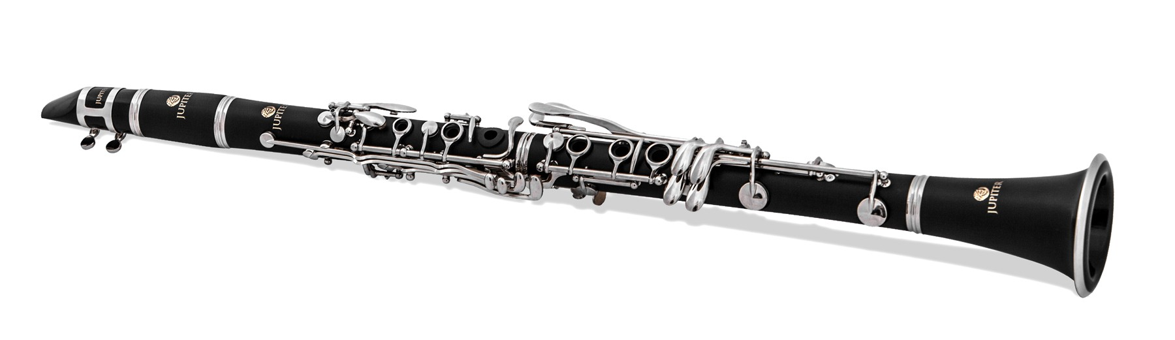
The clarinet, pictured at right, is a wind instrument that behaves like a closed pipe with a fundamental frequency of 130 Hz in air at a room temperature of 25ºC.

(a) What are the frequencies of the next two higher harmonics? (2 marks)

(b) Sketch the particle displacement vs distance envelopes for the fundamental frequency and for the next harmonic frequency above the fundamental for this instrument. (2 marks)

fundamental frequency

next harmonic frequency

(c) Calculate the length of the clarinet. (3 marks)

The clarinet is played so as to produce its fundamental frequency, and the sound is captured by a microphone and feed into an amplifier. Two loudspeakers X and Y are connected in phase to the amplifier and set up facing each other a distance of 8.5 m apart. A person walking from one of the loudspeakers towards the other hears points where the sound is extremely soft, alternating with points where it is loud.
X
Y
Amplifier

8.5 m

(d) Why will the person hear a series of soft and loud points as they walk from one loudspeaker towards the other? (2 marks)

(e) Calculate whether the sound is loud or soft when the person walking between the loudspeakers is 2.92 m from speaker X. (3 marks)

(e) What is the distance between a soft and a loud point? (1 mark)

(f) Determine the number of soft points between the loudspeakers. (2 marks)

Question 18 (15 marks)
A car of mass 1200 kg is being driven along a busy road at a steady speed when the driver, distracted by answering their phone, fails to notice that the lights ahead are red and runs into the back of a stationary 3.5 tonne van waiting at the lights. The car and van lock together after collision and slide to a halt in the middle of the intersection, leaving skid marks measured by the police to be 3.2 m long. The police also estimate that the frictional force acting on the tyres of the skidding vehicles was approximately 60% of their combined weight.

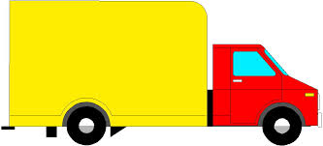
u



(a) Give a value for the frictional force acting on the tyres of the skidding vehicles, and hence calculate the work done by friction in bringing the vehicles to a halt. (3 marks)

(b) State the energy transformation that occurs as the two vehicles skid to a halt. (1 mark)

(c) Hence find the speed of the two vehicles immediately after the car runs into the van (at the beginning of their skid). (3 marks)

(d) Given that momentum is conserved during the collision of the car with the van, determine the speed of the car before hitting the van. (2 marks)

(e) Compare the kinetic energy of the car before collision with the kinetic energy of the car plus van after collision. Account for any difference between the two values. (3 marks)

(f) Compare the force experienced by each vehicle during the collision. Explain why the car driver is more likely to suffer injuries as a result of the collision than the van driver. (3 marks)

Question 19 (13 marks)
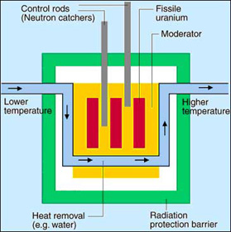
A water-cooled nuclear reactor is shown in the sketch at right. The fuel rods in the nuclear reactor contain the fissile isotope uranium-235, which releases large amounts of energy when it undergoes fission.
The heat produced by the reactor core is removed by the coolant flowing through it, in this case pressurised liquid water, which remains in the liquid state despite increasing in temperature by 160 K after passing through the reactor core.
The masses of various particles involved in a typical fission reaction are given below
mass (uranium-235) = 3.90314 x 10⁻²⁵ kg
mass (barium-141) = 2.34002 x 10⁻²⁵ kg
mass (krypton-92) = 1.52653 x 10⁻²⁵ kg
mass (neutron) = = 1.6750 x 10⁻²⁷ kg

(a) Write a balanced nuclear equation for the fission of a uranium-235 nucleus, after the absorption of a neutron, into barium-141 and krypton-92 nuclei along with the release of more neutrons. (2 marks)

(b) Given the masses listed above, calculate the energy released per fission of a uranium-235 nucleus. (3 marks)

(c) The power output of the nuclear reactor is 250 MW. Calculate the rate at which the fuel rods lose mass in order to provide this amount of power. (2 marks)

(d) Calculate the mass of coolant that must pass through the reactor core every second to maintain it at a stable temperature when it has a power output of 250 MW. (2 marks)

(e) Explain the function of the following components of the nuclear reactor.
(i) the control rods (2 marks)

(ii) the moderator (2 marks)

Question 20 (11 marks)
A girl riding on her bike starts rolling from rest at the top of a steep 10° slope, as shown in the diagram below. The girl and her bike have a combined mass of 65 kg, and the friction force of the road against her tyres as she rolls down the slope is a constant 15 N.
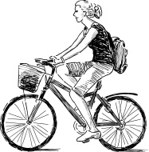
10°
(a) On the diagram, draw in and label the three forces acting on the girl (and her bike) as she starts rolling down the slope. (3 marks)

(b) How large is the normal reaction force of the road pushing on the tyres? (2 marks)

(c) Calculate the size of the net force on the girl as she starts rolling down the slope, and her initial acceleration. (4 marks)

In addition to the 15 N friction force, there is an air resistance force opposing her motion down the slope, which increases quadratically with speed according to the formula
F = 1.2 v² , where F = air resistance force (in N) and v = her speed (in m/s).
(d) Calculate the maximum speed she will reach rolling down the slope on her bike. (2 marks)

END OF SECTION TWO
Section Three: Comprehension (36 Marks)
This section has two (2) questions. Write your answers in the spaces provided.
Suggested working time: 36 minutes.

Question 21 LOCATION OF A SOUND (15 marks)

(Paragraph 1)
The precise method by which a human being is able to discover the location of a particular sound in relation to themselves has exercised the minds of scientists for many years. Lord Rayleigh, in his Theory of Sound published in 1896, comments briefly on the theory prevalent at the time. This was that the effect of the bulk of the head between the two ears produced a sound shadow, and thereby caused an amplitude difference in the sound reaching the two ears from a given source. Rayleigh pointed out that this theory could only operate at frequencies above about 1000 Hz, that is at frequencies above that at which the physical distance between the ears is equal to one wavelength. He suggested that a possible explanation for the perception of sound direction at low frequencies might be the difference in time of arrival of the sound wave from a source at the two ears.

(Paragraph 2)
Early workers conducting investigations into sound localisation were very limited in their activities by their lack of electrical equipment, and were forced to use clicks and other noises as sound sources. Furthermore, the rooms that they used for their experiments were far from good acoustically, and so the positions of the sound sources were confused by reverberation effects. However the early experimenters established that it is possible to locate noises more easily than pure tones, and that it is possible to distinguish sounds appearing from the right or the left.

(Paragraph 3)
Stevens and Newman, in 1934, devised an open-air experiment in order to overcome the difficulties of sound reflections. They mounted a swivel chair on top of the roof of one of the buildings at Harvard University. The source of the sound was mounted at the end of a four metre arm that could be moved noiselessly in a complete circle on a horizontal plane level with the listener’s ears. The sound generator was a loudspeaker that could produce pure tones and various noises, such as clicks. It was found that the listener hardly ever confused the positions of sounds that were to the right or left, but, depending upon the type of sound used, fairly frequent confusion of whether the sound was in front or behind took place. It was found that pure tones at low frequencies could be localised with reasonable accuracy, as could tones at very high frequencies, but there was a band of middle frequencies between 2000 and 4000 Hz where localisation appeared to be more difficult.

(Paragraph 4)
Stevens and Newman concluded that the observed results from their experiments were “consistent with the hypothesis that the localisation of low tones is made on the basis of a phase difference at the two ears, and that the localisation of high tones is made on the basis of intensity differences”. These experimental results seemed to confirm the earlier theories attributed to Rayleigh and others.

(a) Briefly explain what is meant by each of the following expressions
(i) …“an amplitude difference in the sound reaching the two ears”… (paragraph 1)
(1 mark)

(ii) …“pure tones”… (paragraphs 2 & 3) (1 mark)

(iii) …“a phase difference at the two ears”… (paragraph 4) (2 marks)

(b) What were the “difficulties of sound reflections” (paragraph 3) found by early experimenters in rooms which were “far from good acoustically” (paragraph 2)? (2 marks)

(c) Why does the frequency have to be above about 1000 Hz for the amplitude difference effect to be significant? (paragraph 1) (3 marks)

(d) The information provided in paragraph 1 would enable you to make a very rough estimate of the speed of sound provided you make one further estimate of a simple measurement. Make an estimate of this simple measurement, and hence estimate the speed of sound. (3 marks)

(e) If the ear does detect sound direction for low frequencies by differences in times of arrival at the two ears, make a rough estimate of the time difference our hearing mechanism must be detecting. (paragraph 1) (3 marks)

Question 22 RESISTIVITY OF A METAL (21 marks)
Resistivity, ρ, is an intrinsic property of a material, like density or specific heat, and is independent of the dimensions of a particular piece of the material, depending only on the nature of the material. Resistivity is equivalent to the resistance of a piece of material that is 1 m long and of cross-sectional area 1 m². For a metal wire of length l and cross-sectional area A, the relationship between the resistance R of the wire and the resistivity ρ of the metal is given by

Two students carried out an investigation using the voltmeter-ammeter method to determine the resistance of different lengths of the same metal wire, of diameter 0.28 mm. Their results are shown in the table below:

Length of wire (m) | Ammeter  reading (A) | Voltmeter  reading (V) | Resistance (Ω)
0.5 | 2.79 | 2.12
1.0 | 1.51 | 2.33
1.5 | 1.23 | 2.85
2.0 | 0.980 | 3.09
2.5 | 0.840 | 3.27
3.0 | 0.760 | 3.52

(a) For the investigation as described above, identify the following variables. (4 marks)

Independent variable:

Dependent variable:

Two controlled variables:

(b) Complete the resistance column in the table above. (2 marks)

(c) Draw the circuit that the students used to obtain these results. (3 marks)

(d) Use this data to plot a linear graph of resistance versus length of wire on the graph paper provided below. (4 marks)


(e) Calculate the gradient of your graph. (4 marks)

GRADIENT =

(f) Use the gradient of the graph to find the resistivity of the metal. (4 marks)

END OF PAPER

EXTRA WORKING SPACE

